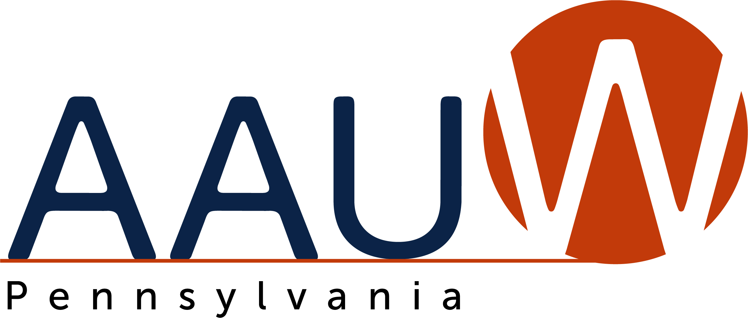
Gateway to Equity Award 2023 - 2024

Awarded to individuals, groups or organizations that have shown, by action and philosophy, that they advance equity for women and girls through advocacy, education, philanthropy, or research.

Presented to

[Recipient’s Name Here]

For

[Specifics Here]

______________________________________ ________________
AAUW Branch President Date

