Deeper in Debt: Women and Student Loans
* Required
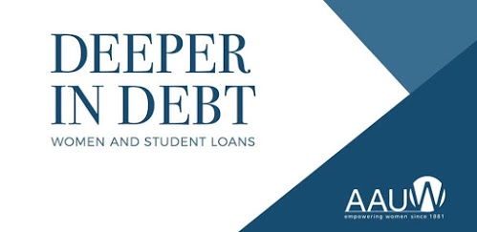
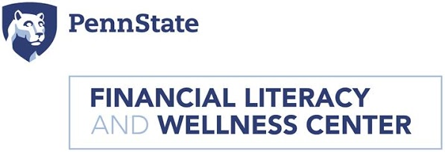
A new study conducted by the American Association of University Women estimates that women hold almost two-thirds of the country’s $1.3 trillion dollars in student debt. Women incur larger student loan debt than men, and after graduation earn an average of 22% less than their male counterparts. These factors and others leave women with less disposable income, which takes an average of two years longer to pay off student loan debt.
To learn more about women and student loans, and to explore solutions, AAUW Pennsylvania, AAUW State College and the Penn State Financial Literacy & Wellness Center will host a panel discussion on this topic. Federal and State funding of higher education, financial aid issues, academic choices, pay gaps in gender and race, and advocacy ideas for individuals will be discussed. This program will empower women to make life-changing choices that could dramatically affect their financial future. Join us!
Tuesday, October 10th, Smeal Business Building, Penn State-University Park
Pre-program reception with light refreshments - Atrium Foyer outside Room 110
5:45 - 6:20 pm
Program - Room 110
6:30 - 7:45 pm
To download the Powerpoint presentation and Executive Summary, please visit https://financialliteracy.psu.edu/deeper-in-debt-women-and-student-loans/
The Penn State Smeal College of Business is located at the corner of Park Avenue and Shortlidge Road on Penn State's University Park campus. Public parking is available in the East Parking Deck on Bigler Road, cost is $1.00 per hour.
There will be a drawing at the program for two $50 gift cards to the Penn State Book Store. Must be present to win!
For remote attendance via Zoom: Join from PC, Mac, Linux, iOS or Android: https://psu.zoom.us/j/526969836
For additional information on AAUW or questions in regard to this event: http://www.aauwstatecollege.org
Registration is requested but not required!
Name *
Email Address *
Status
Student
Community Member
Other
Never submit passwords through Google Forms.

