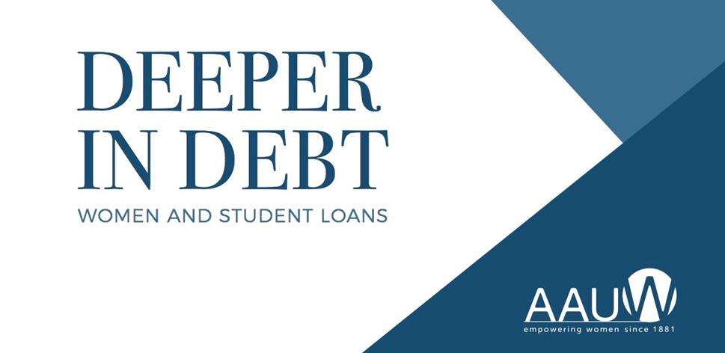

Date
Time
Place

A new study conducted by the American Association of University Women estimates that women hold almost two-thirds of the country’s $1.3 trillion dollars in student loan debt. Join us for a panel discussion on this topic. It will empower women to make life-changing choices that could dramatically affect their financial future.

(Special features about the program
that you’d like to highlight.)

ADVANCE REGISTRATION REQUESTED:
(PROGRAM REGISTRATION HYPERLINK)

INSERT CO-SPONSOR LOGO(s) HERE
PROGRAM
SPONSOR
LOGO
PROGRAM
SPONSOR
LOGO

